***Chapter 19 – Enzymes***

Outline

Enzymes Influence Reactions

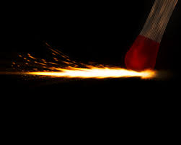**Activation energy** – the energy that supplies the force needed for the two substances to collide and break the chemical bonds.

Example – striking a match

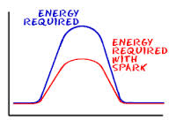**Catalyst** – a substance that speeds up the rate of a reaction without being permanently change or used up itself.

Example – enzyme breaking food down to use as energy

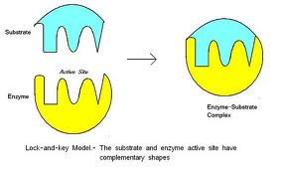**Substrate** – the substance on which the enzyme works

Example – enzymes break down food

Protease breaks down protein

Amylase breaks down carbohydrates

Lipase breaks down fats and oils

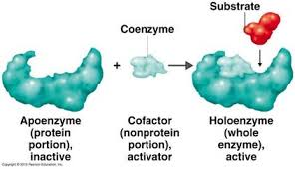**Active site** – the area of the enzyme that fits into the shape of a substrate

**Coenzymes** – helps the enzyme do its job

What Affects Enzyme Activity?

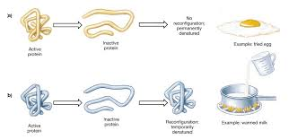**Temperature –** can increase or decrease activity depending on hot or cold

*Cold* = no activity

*Cool* = slow activity

*Warm* = increases activity

*Hot* = no activity because protein is denatured

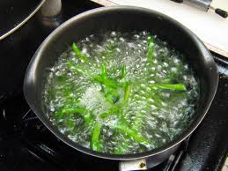**Blanching** – briefly immersing food in boiling water

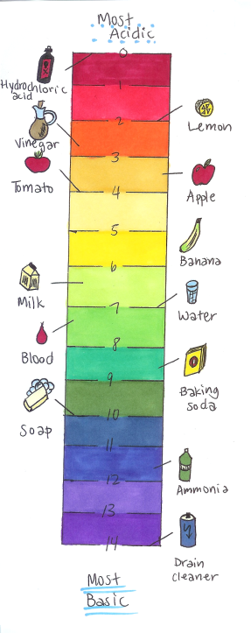

**pH** – most enzymes function best at a pH between 7-10, if rises or falls beyond this range, activity decreases.

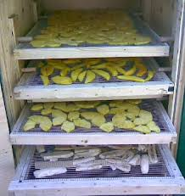**Water** – provides a medium in which enzymes and their substrates can interact

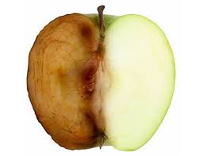**Enzymatic Browning** – when enzymes produce discoloration fruits and vegetables

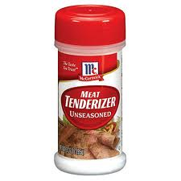**Papain** – dry powder made from the paya fruit and salt to break down the muscle fiber of meat